**Touch**

**Typing**

**Class Five**

**Lab 8**

|  |
| --- |
| Lab Objectives:  * Words * The  Vowels E,  U and  I |

# Finger Placement

## Follow the colours and finger numbers in the next chart to practise lines of each pattern or word in the following exercises. Visualize where the letter keys are and use the fingers shown.

## Using only the four Left hand letter keys, D and F on the Home Key row with E and R on the row above we can feel out the word ‘fred’ which is one of over 30 words that can be formed from only these four letters.  Two other examples are, referee and feeder.

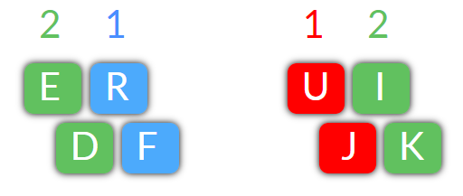

# Exercises - 1

## Do each exercise two times - twice in a row.  Repetition is your best friend.   Repetition is your best friend.  Did we say that repetition is your best friend.  It's true.  Repetition...

### Left Hand

## deed frrf deer reed red deed frrf deer reed red deed frrf deer reed red

## free freed fred feed fed free freed fred feed fed free freed fred feed fed

## reef reef ref ref refer refer defer defer referred deferred refereed

# Exercises - 2

### Right hand

## juuj juuj juju juju kiik kiik kiki kiki juki juki kiju kiju jiku jiku juik juik ijku

## jj uu kk ii jj uu kk ii jk jk ui ui jk jk ui ui jk ui jk ui ijku ujik ukij ujik ikij ikiu



# Exercises - 3

### Both Hands - words

## jude jude dud dud dude dude rude rude due due rudder rudder

## fur fur fir fir fire fire fired fired ride ride fried fried rider rider

## kid kid did did die die died died dried dried ride ride drier drier

## -

# Try These Fun Phrases

## red deer feeder; feed freddie; red fire; free feed; fried deer; dier ride;

## eddie died; free ride; eddie fired fred; did eddie die; dier rider fried;

## edifier rider dude freed red fur deer; kidder eddie rudder fed red deer;

## freed fed red deer died; referrer fred fuji fried freed fed red deer;

## duke jeered rude referee jed; did irked kirk fire rude jerk; jude dried;